|  |  |
| --- | --- |
|  |  |
|  |

**NI SPEC SERVER PROXY**

Overview 2

Software Requirements 2

Installation 2

How to run? 2

How to communicate TestStand with SLE? 3

How to start the proxy on windows startup automatically? 5

Note: 5

# Overview

NI Spec Server Proxy enables users to exchange data between SystemLink Enterprise (SLE) and NI TestStand without affecting the TestStand-SpecificationComplianceManager (SCM) workflow.

Related Information:

* [TestStand-SCM Integration](https://www.ni.com/docs/en-US/bundle/teststand/page/communicating-with-an-scm-server-in-teststand.html)

# Software Requirements

|  |  |
| --- | --- |
| **NI Packages Dependency** | **Version** |
| NI TestStand | 2023 Q4 or above (64-bit) |
| NI SystemLink Client | 2024 Q1 or above |

# Installation

1. Open Command Prompt.
2. Run the below command to install the whl file,

"*C:\Program Files\National Instruments\Shared\Skyline\Python\3.8\python.exe" -m pip install* ***<path_to_ni_spec_server_proxy-X_X_X-py3-none-any.whl>***

Note:

* Require Internet access to install the external dependencies of NI Spec Server Proxy

# How to run?

* Run **spec-server-proxy.bat** file available in the **batch_files/** folder  
  A close up of a logo

  Description automatically generated

Or

1. Open Command Prompt.
2. Run the below command to start the proxy service,

*"C:\Program Files\National Instruments\Shared\Skyline\Python\3.8\python.exe" -m ni_spec_server_proxy*

# How to communicate TestStand with SLE?

1. Launch NI SystemLink Client and connect to SystemLink Enterprise as per [instructions](https://www.ni.com/docs/en-US/bundle/systemlink-enterprise/page/setting-up-systemlink-client.html#:~:text=Search%20for%20and%20install%20NI,which%20you%20want%20to%20connect.).
   1. If the SLE version is 2024-04 or older, update the API key in the master.json file at - *"C:\ProgramData\National Instruments\Skyline\HttpConfigurations\http_master.json".*
   2. Refer to the [instructions to Create an API key](https://www.ni.com/docs/en-US/bundle/systemlink-enterprise/page/creating-an-api-key.html).
2. Run the NI Spec Server Proxy. Refer to How to run?
3. Open NI TestStand Sequence Editor
4. To import product specifications from an SLE server into TestStand, Launch the Manage Specifications dialog box by selecting *Tools » Import/Update from Specification Compliance Manager (SCM)* from the TestStand Sequence Editor menu bar.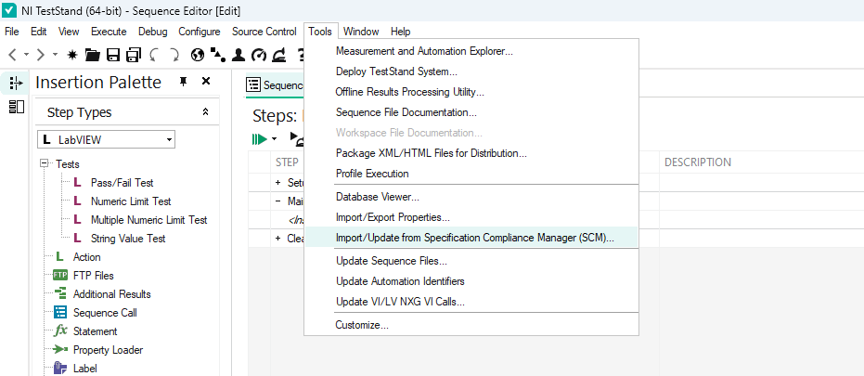
5. Enter the credentials in the dialog box,
   1. Server - *http://localhost:8000*
   2. API token – *None*

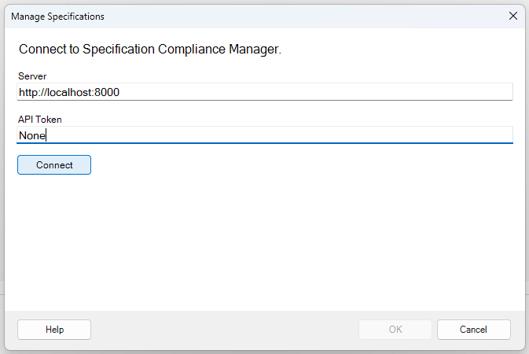

1. Click on the *Connect* button.
2. Once the server is connected, the Product drop-down lists the **PartNumber** available in SLE.
3. Select a PartNumber and select the categories to import the specifications.
4. Use the specification details imported into FileGlobals.SCM_Specifications in the Test Sequence for Test Automation and measurement data logging with test conditions using the TestStand SCM Integration Workflow.

# How to start the proxy on windows startup automatically?

1. Download the **spec-server-proxy.bat** file available in the batch_files/ folder.
2. Press **Win + R** to open the Run dialog.
3. Type **shell:startup** and press Enter.

1. The Startup folder opens.
2. Place the **spec-server-proxy.bat** file in the Startup folder.
3. This batch file will start whenever the PC is turned on.

Note: Do Not close the NI Spec Server Proxy window. The proxy service will terminate when this window is closed.

